UID EXPERIMENT 8
NAME: SHERIN KATHERINA D ROLLNO: 240701495

Home Screen (Online Shopping App)
The Home Screen is the first interface the user interacts with. It provides quick access to products, categories, and offers, ensuring a smooth and engaging shopping experience.

Features
- Search Bar
Located at the top, allowing users to quickly search for products.
- Menu Icon
Provides access to navigation options such as profile, orders, wishlist, and settings.
- Product List (Card Format)
Products are displayed as cards, including:
  - Product image
  - Product name
  - Price
  - Discount (if available)
Example products:
  - Mobile Phones
  - Headphones
  - Laptops
- Category Buttons
Enables filtering of products by category:
  - Electronics
  - Fashion
  - Home & Kitchen
- Offers / Deals Section
Displays ongoing discounts, deals, and promotions.
- “Add to Cart” / “Buy Now” Buttons
Allows users to quickly purchase or save items.

User Interaction
- Users can scroll through the list of products.
- Users can search for specific items using the search bar.
- Users can tap on a product card to view detailed information.
- Users can add items to the cart or proceed to buy instantly.
- Users can filter products using category buttons.

Purpose
This screen helps users easily browse products, discover deals, and make quick purchasing decisions in an efficient and user-friendly manner.
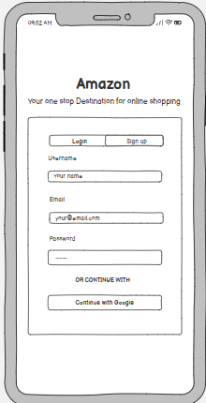

Login Page (Online Shopping App)
The Login Page is the entry point for users to access their account securely. It allows existing users to log in and new users to register.

Features
- App Logo / Title
Displays the brand name or logo at the top.
- Username / Email Field
Input field for users to enter their registered email or username.
- Password Field
Secure input field for entering the password (masked for privacy).
- Login Button
Allows users to log into their account.
- Sign Up Option
Redirects new users to the registration page.
- Forgot Password Link
Helps users recover their account if they forget their password.
- Social Login Option (Optional)
Allows users to log in using platforms like Google.

User Interaction
- Users enter their email/username and password.
- Users click the Login button to access their account.
- New users select Sign Up to create a new account.
- Users who forgot their password can click Forgot Password to reset it.

Purpose
This screen ensures secure authentication and provides easy access for users to enter the shopping application and manage their accounts.
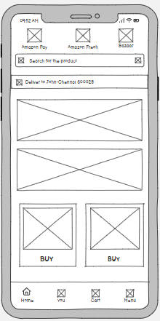

Product Display Page (Online Shopping App)
The Product Display Page shows detailed information about a selected product. It helps users understand the product features and make purchasing decisions.

Features
- Product Image
Displays high-quality images of the product (with zoom or multiple views).
- Product Name & Brand
Clearly shows the name and brand of the product.
- Price & Discount
Displays the current price, original price, and discount (if available).
- Product Description
Provides detailed information about the product, including features and specifications.
- Ratings & Reviews
Shows customer ratings and feedback.
- Availability Status
Indicates whether the product is in stock.
- Quantity Selector
Allows users to choose the number of items.
- Action Buttons
  - Add to Cart
  - Buy Now

User Interaction
- Users can view images and scroll through product details.
- Users can read descriptions and reviews before purchasing.
- Users can select quantity if needed.
- Users can click Add to Cart to save the product.
- Users can click Buy Now to proceed directly to checkout.

Purpose
This screen provides complete product information, helping users make informed decisions and proceed with purchasing confidently.
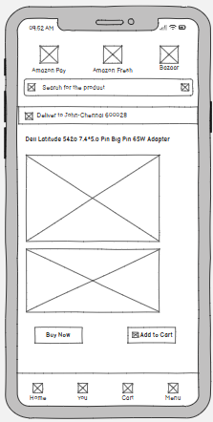

Order Confirmation Page (Online Shopping App)
The Order Confirmation Page is displayed after a successful purchase. It confirms that the user’s order has been placed and provides all necessary details about the order.

Features
- Confirmation Message
Displays a message such as “Your order has been placed successfully!”
- Order ID / Reference Number
A unique ID for tracking the order.
- Order Summary
Includes:
  - Product name(s)
  - Quantity
  - Total amount paid
- Delivery Details
Shows shipping address and estimated delivery date.
- Payment Details
Displays the payment method used (e.g., UPI, Card, Cash on Delivery).
- Track Order Button
Allows users to track the delivery status.
- Continue Shopping Button
Redirects users back to the home page.

User Interaction
- Users can view order details and confirmation message.
- Users can click Track Order to monitor delivery status.
- Users can return to shopping using Continue Shopping.

Purpose
This screen reassures users that their order has been successfully placed and provides all necessary details for tracking and reference.
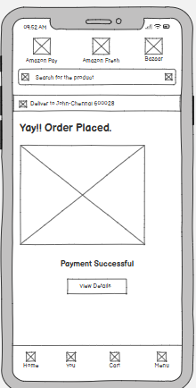
Prototype link:- https://balsamiq.cloud/skcg7wa/pp5nekg/rA310

